## Supplementary material of

Towards the bio-personalization of music recommendation systems: a single-sensor EEG biomarker of subjective music preference

**Dimitrios A. Adamos*1,3, Stavros I. Dimitriadis2,3 and Nikolaos A. Laskaris2,3**

*Asterisk indicates corresponding author*

1School of Music Studies, Aristotle University of Thessaloniki, 54124 Thessaloniki, Greece

2AIIA Lab, Department of Informatics, Aristotle University of Thessaloniki, 54124 Thessaloniki, Greece

3Neuroinformatics GRoup, Aristotle University of Thessaloniki, Greece - <http://neuroinformatics.gr>

Correspondence to:

**Dr. Dimitrios A. Adamos**

School of Music Studies, Faculty of Fine Arts,

Aristotle University of Thessaloniki,

GR-54124 Thessaloniki, GREECE

tel: +30 2310 991839

Fax:+30 2310 991815

E-mail: dadam@mus.auth.gr

## A. Statistical Testing of MI-values using surrogate data

In the case of actual experimental data, an obtained MI-value can be compared against a control distribution so as to infer if a non-zero MI indicates a ''true'' coupling or such an MI-level can appear even in the case of no coupling (as a result of approximate computations based on finite-size samples). We adopted the well-known technique for creating surrogates [3], so as to form a control distribution of MI-values. The overall statistical methodology was carried for every frequency pair (*f*1, *f*2) as follows.

We form distributions of MI measurements {sMI(r)}r=1:500 for neutral and favorite music, corresponding to the case of no CFC, by repeatedly applying the steps in each case:

**step_i**: Generate a surrogate time-series y2(t) by randomizing the phases of x2(t) while keeping its spectrum profile constant.

**step_ii**: Estimate 

The original value of MI-index, MIo=MI(x1(t),x2(t)) is then compared to the distribution of surrogates {sMI(r)}. A *p*-value is assigned by estimating the proportion of surrogates sMI-values that are lower than MIo. This reflects the statistical significance of testing the hypothesis that the observed MI might arise from signals with no PAC-type coupling.

We verified statistically, that there was significant CFC during listening to music. In short, we compared the observed oMI values in the actual data of a single-subject, with the MI values when -by construction- there had been no cross-frequency coupling. The comparison was performed independently for every bin in the comodulogram and resulted to a p-value. To account for the effect of multiple comparisons, the derived p-values were corrected using the FDR method [1] with the expected fraction of false positives set to q ≤ 0.01. Particular examples of this statistical testing can be seen below.

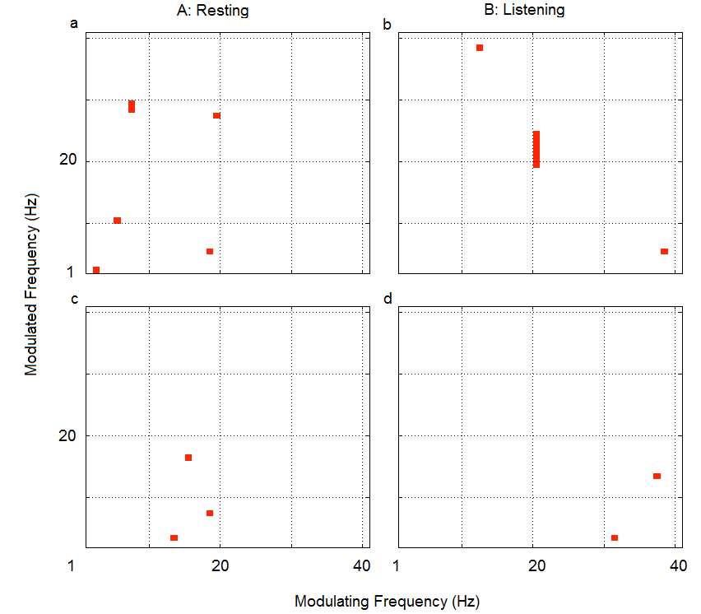

Supplementary Figure S1: Examples from statistical testing of MI values associated with the comodulograms depicted in Figure 5; for resting (Fig. 5a, 5d) and listening to music (Fig. 5b, 5e). Denoted are the pixels (frequency pairs) associated with statistically significant contrast level (after FDR correction).

## B.Statistical testing of discriminability J

Using a randomization procedure [2] we assessed the statistical significance of each obtained J-value. To this end, we assigned randomly the corresponding 28 BM-values to the ‘neutral’ and ‘favorite’ group and estimated the (randomized) discriminability level Jr. By repeating this randomization step 100 times, a distribution of discriminability levels was formed, that corresponded to the absence of any systematic differences between listening to ‘neutral’ and ‘favorite’ music and used to identify the upper J-level with P<0.01

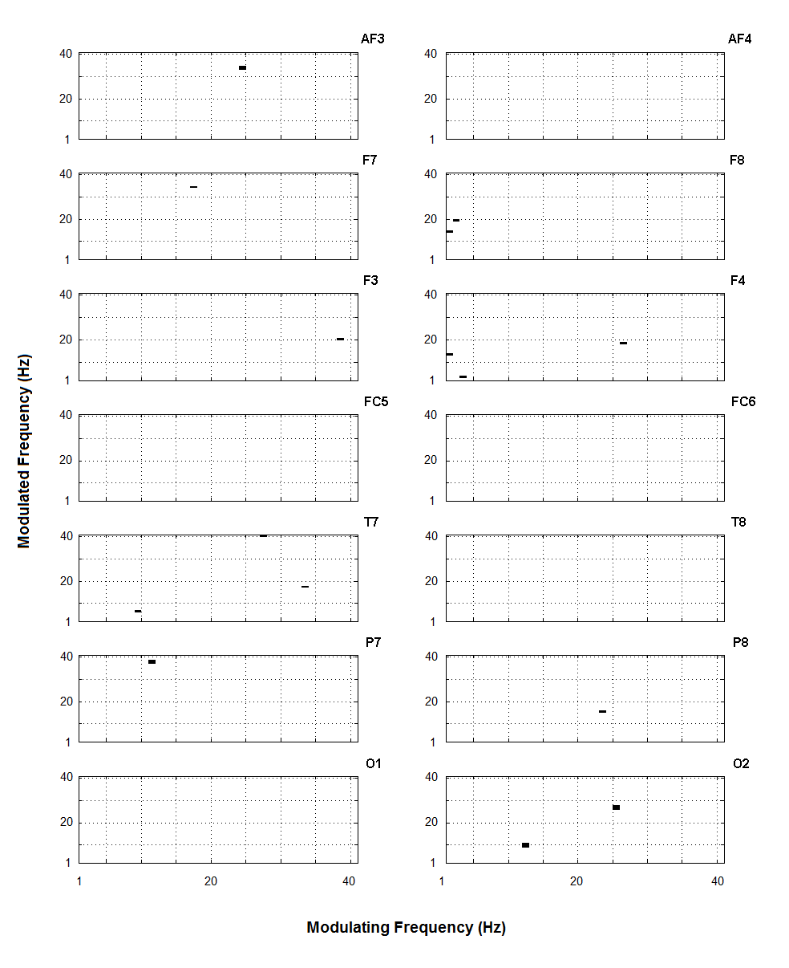

Supplementary Figure S2: Statistical testing of J-levels shown in the separability maps of Fig.6 (T=80). Marked pixels correspond to statistically significant J-levels. (P<0.01)

## C. Contrasting PSD estimates

The discriminability, regarding the task ''Neutral'' vs ''favorite'' music was measured for all sensors as a function of frequency by introducing a factor in fully analogy with the normalized MI



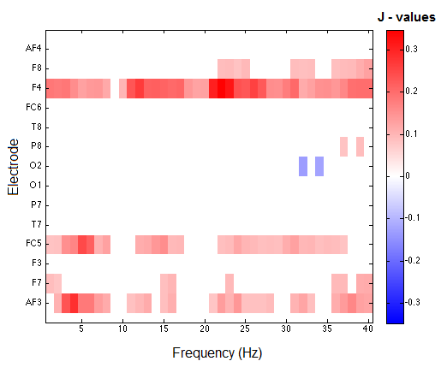 Power spectral density(PSD) was estimated for frequency-bins of 1 Hz width, by employing the Welch's method**,** based on signals lasting for 80 sec. Based on these estimates, obtained for all participants, J scores were derived at the level of group-analysis

Supplementary Figure S3: Separabilty measurements for estimates of Power Spectral Density. Color coding, in full analogy with Fig.6, denotes the sign of ‘favorite’-‘neutral’ difference. Pixels with bright red(blue) color correspond to frequencies with systematically higher(lower) signal power during listening to favorite music.

## D. References

1. Y. Benjamini, Y. Hochberg, Controlling the False Discovery Rate: A Practical and Powerful Approach to Multiple Testing, J. R. Stat. Soc. Ser. B Methodol. 57 (1995) 289–300.
2. P. Good, Permutation Tests, Springer New York, New York, NY, 2000.
3. J. Theiler, S. Eubank, A. Longtin, B. Galdrikian, J. Doyne Farmer, Testing for nonlinearity in time series: the method of surrogate data, Phys. Nonlinear Phenom. 58 (1992) 77–94.